73.01.02b
From Robert Fitzgerald
MEL 18670, National Herbarium of Victoria, Royal Botanic Gardens Melbourne.

Survey Office
Sydney
2 Jan 73
Dear Sir,
I enclose a specimen of an Hibiscus from Queensland which I have raised from seed. It appears to me to be new or at least not described in the "Flora". It is a very handsome plant and will I think become a small tree. The only one that has as yet flowered being seven feet high and robust though only one year and a half old. Its large wrinkled glaucous leaves give it a very peculiar and attractive appearance. The stem and branches are remarkably smooth with the exception of here and there a few conical prickles. The flower are axillary and solitary. They are of the very brightest glossy crome yellow or rather more orange, and often quite flat from the dark coloured centre to a spread of four inches. They are much more solid in texture than any other native Hibiscus I am acquainted with. The bud is peculiar. The bracts or involucre being mature long before the bud is of any size – thus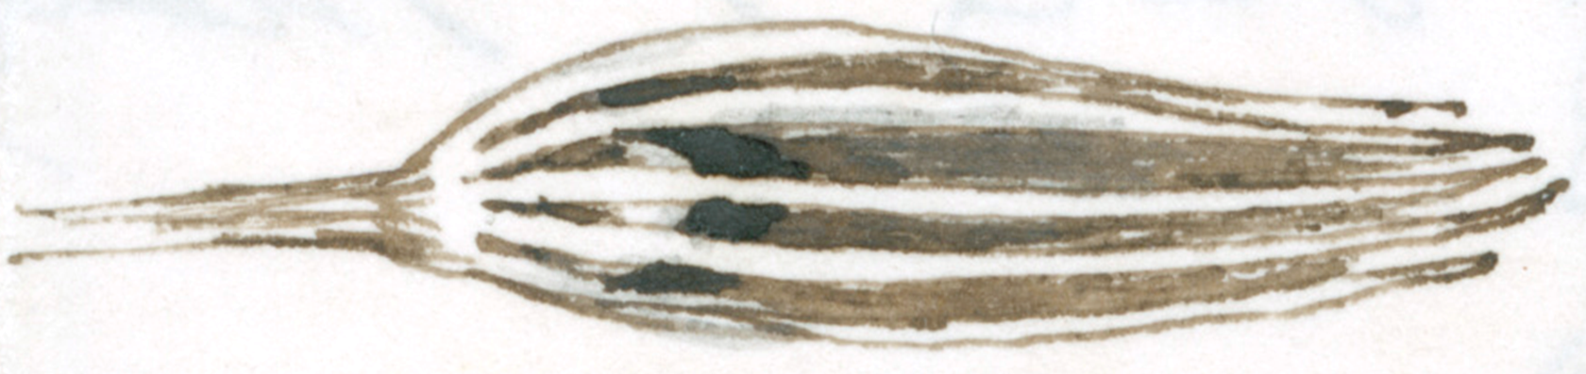 I should be much pleased if it turns out to be new as with the exception of the scarlet (Rosa semensis?) it is the finest Hibiscus I have ever seen. You will be glad to hear that the Government have determined to put a sum of one thousand pounds on the estimates for the publication of my Orchids – For any hints as to how it would be best carried out I should feel much obliged.
I have made a drawing of Phajus "inversus" and will send it to you on the first opportunity. There is another inverted (?) Phajus in Blume P. flavus. I am inclined to think that mine is not a true species as regards the inversion I find from my drawing of P. grandifoliu[s] (Blumii?) that the flowers are all at first inverted, that is before they fully open. I must send you flowers of what I have taken to be P. grandifolius (from Mr McLeay) when next it is in flower as I have doubts respecting its being the same as from the Tweed. It may be P. Blumii
I remain Dear Sir
Yours truly
Robt D. Fitzgerald

Hibiscus Rosa semensis
Phajus "inversus"
Phajus Blumii
Phajus flavus
Phajus grandifolius

MS found with specimen of Hibiscus fitzgeraldi collected by Fitzgerald and named by M for him (B74.10.01, p. 242). Annotation in pencil by M: 'Hibisc.[divaricatus Grat.] var'. M's specimen label also attached to specimen sheet: 'Hibiscus Fitzgeraldi FvM | Bowen's River | Fitzgerald'.
Hibiscus was treated in Bentham (1863-78), vol. 1, pp. 207-18.
73-01-02b_image01.jpg.
Hibiscus rosa-sinensis?
See also R. Fitzgerald to M, 27 January 1873 (in this edition as 73-01-27a).
No publication of Phajus inversus has been found (APNI, accessed 15 November 2020).
Blume (1858), pp. 5-6 and Plate 3?
Blumei?

